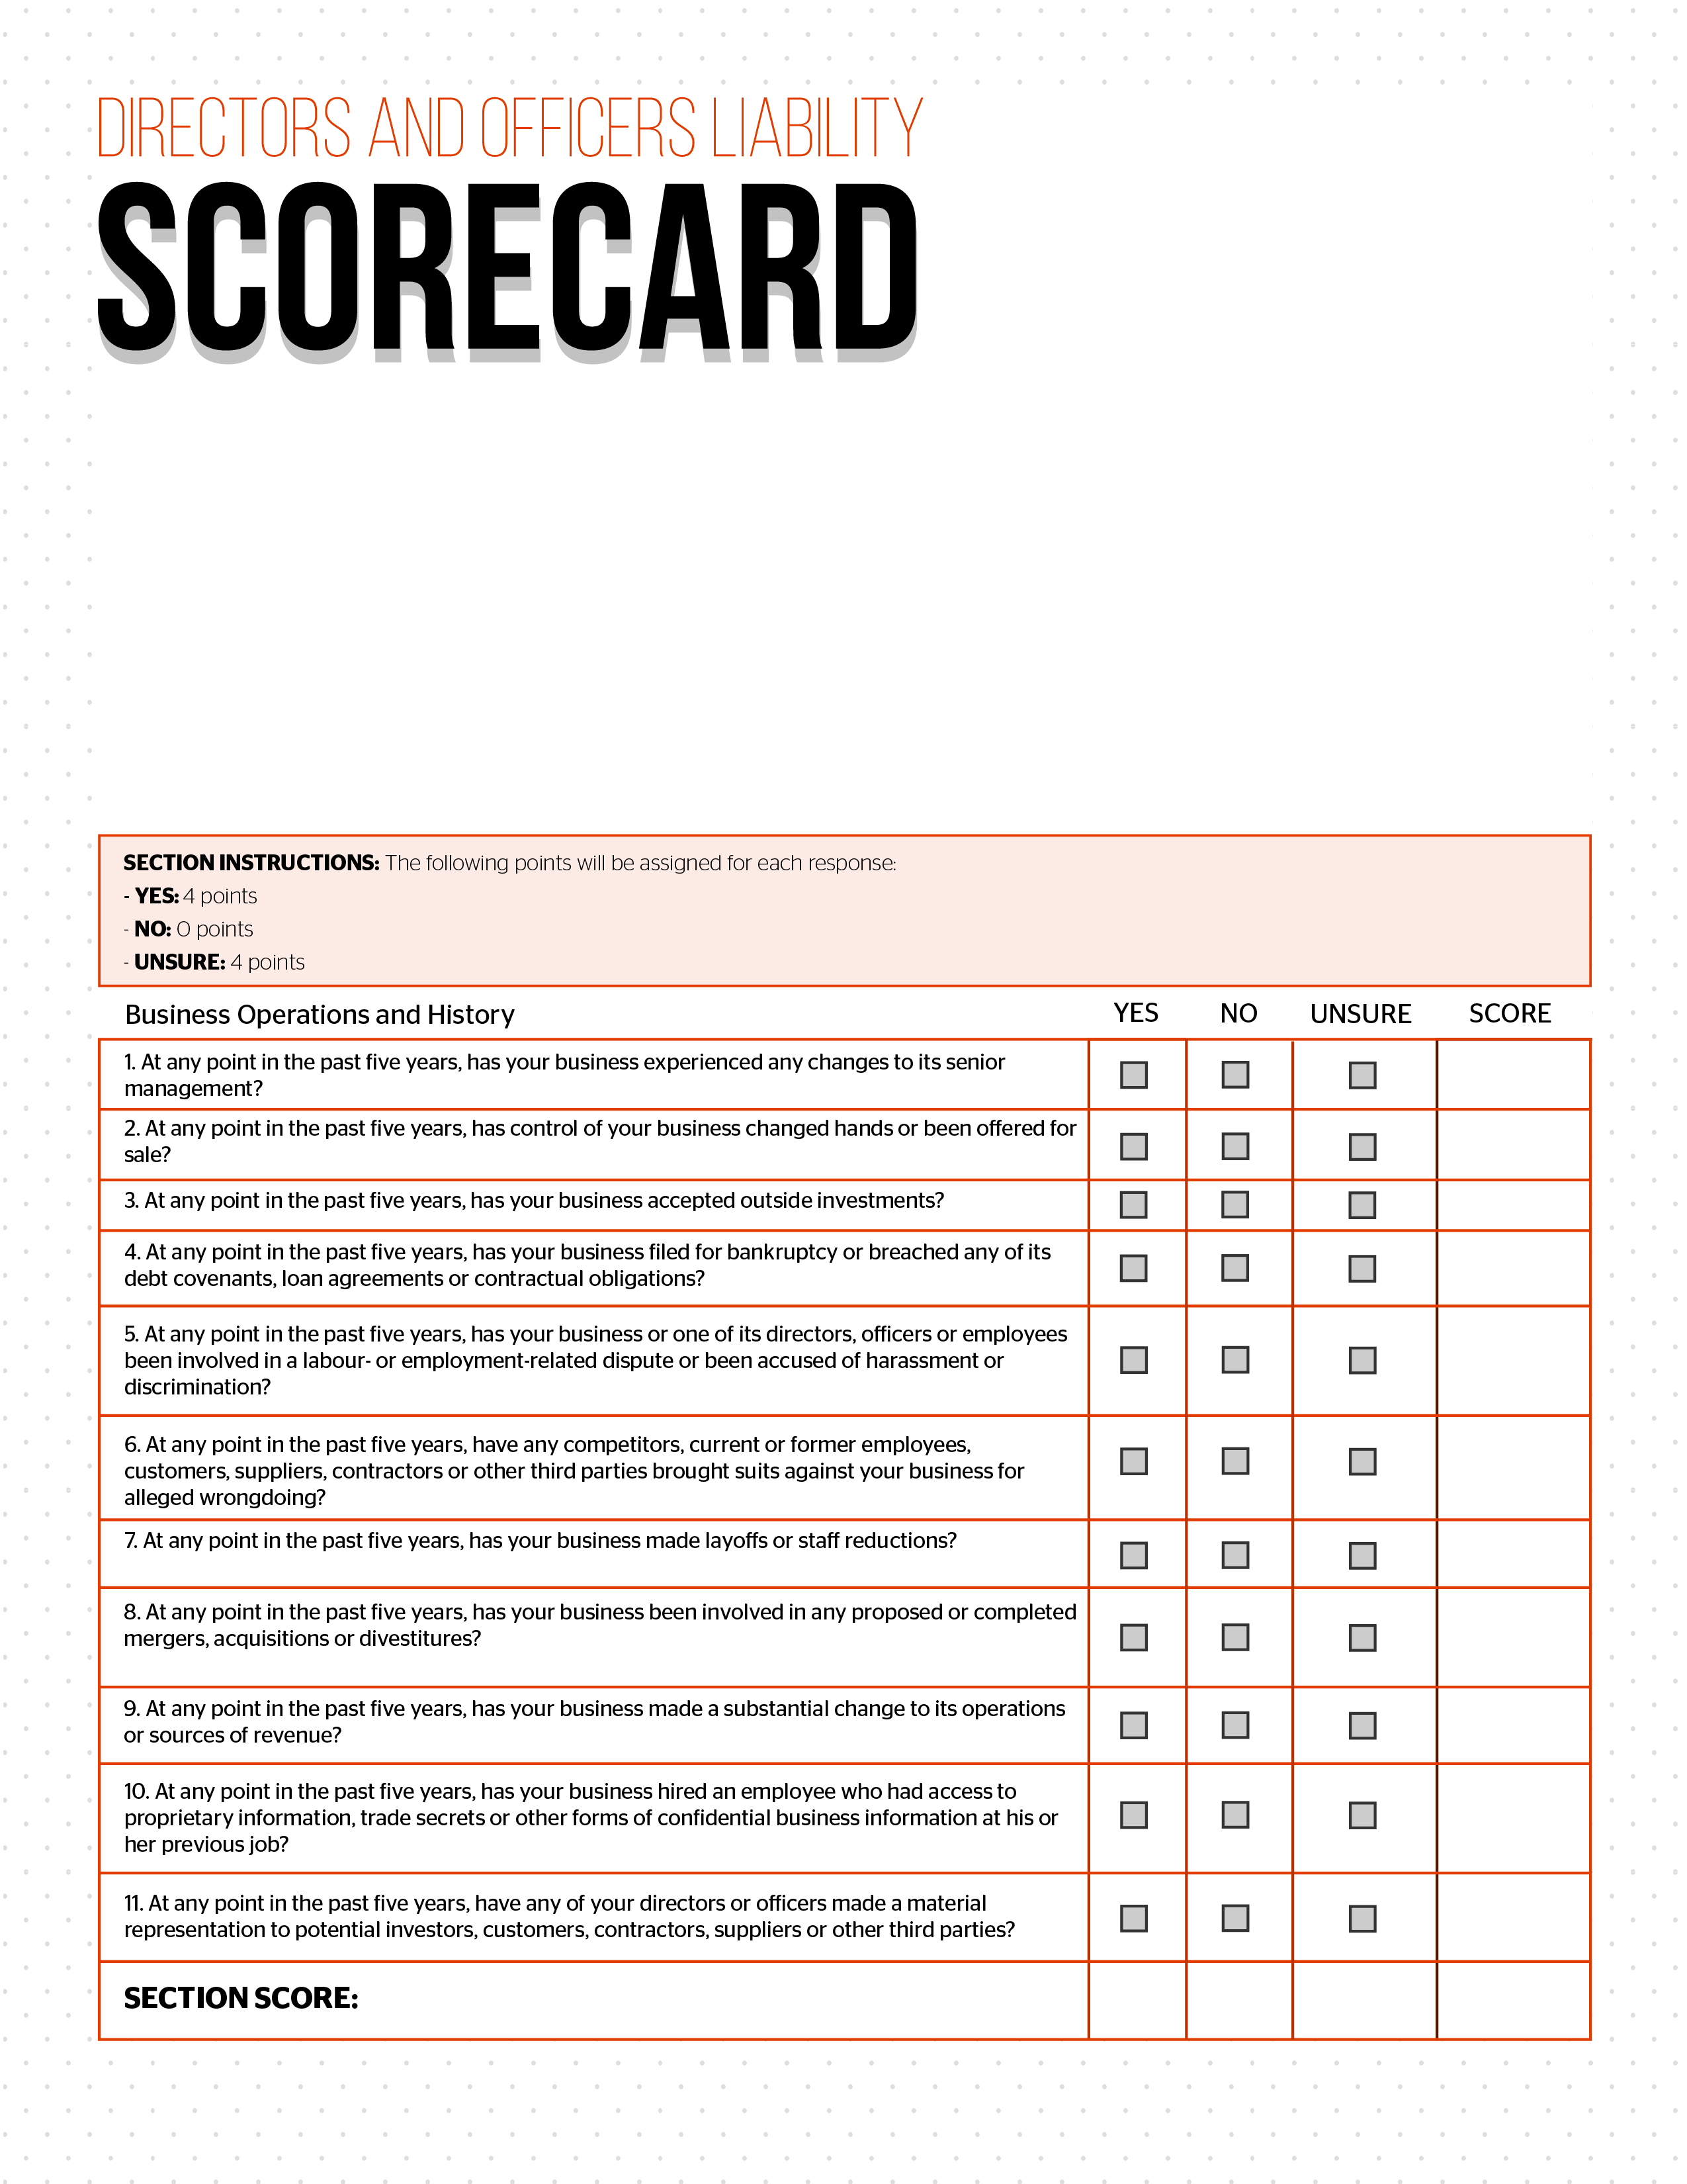
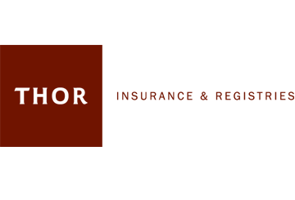
© 2016 Zywave, Inc. All rights reserved.

Claims against directors and officers are becoming increasingly common. In fact, according to recent estimates, 1 out of every 3 Canadian businesses has faced a claim related to their directors and officers in the past decade. Your business and its directors and officers could be sued by customers, current or former employees, competitors, regulators, creditors, vendors or even investors. What’s more, this can happen even if your company is not a large, publicly traded organization.

The cost of defending directors and officers (D&O) claims can run well into the six figures, leaving a business financially crippled. Even worse, your directors and officers put everything they have on the line, because in the event of a D&O liability claim, even their personal assets may be at risk. As a result, D&O liability insurance has become an essential component of most businesses’ insurance portfolios.

To help businesses better understand the level of risk their directors and officers face, Thor Insurance & Registries Ltd has developed this Directors and Officers Liability Scorecard.

Instructions: Please note that each section will have its own instructions related to scoring. Please review them carefully. After you have completed all of the sections to the best of your ability, add up your score and determine your level of risk by utilizing the chart at the end of this document.



